Weekly Construction Progress Report – Week 35
Harrow Bay Offshore Wind · 24 Aug – 30 Aug 2026
Elena Márquez · 31 August 2026 · HB-PM-RPT-2026-W35

1. Summary
No monopile was installed this week; the total remains 12 of 40. The foundation campaign is 3 piles behind the Rev 2 baseline (15 planned). Waiting on weather amounted to 26 hours.
Area | Status | Comment
Overall schedule | Red | 12/40 monopiles vs. 15 planned
Foundations | Red | TPs installed: 12
Offshore substation | Green | Topside installed 19 Aug
Cables | Red | Export cable 2 delay – HB-RISK-017
HSE | Green | No incidents

2. Progress
Metric | This week | Cumulative | Plan (cum.) | Variance
Monopiles installed | 0 | 12 | 15 | -3
Transition pieces installed | 1 | 12 | – | –
Waiting on weather (h) | 26 | 332 | – | –
Persons on board (avg.) | 103 | – | – | –
Man-hours MV Sea Atlas | 8,904 | 170,637 | – | –
Lost time injuries | 0 | 0 | 0 | 0
Recordable injuries | 0 | 1 | – | –
Near misses reported | 0 | 4 | – | –
HSE observation cards | 29 | – | – | –

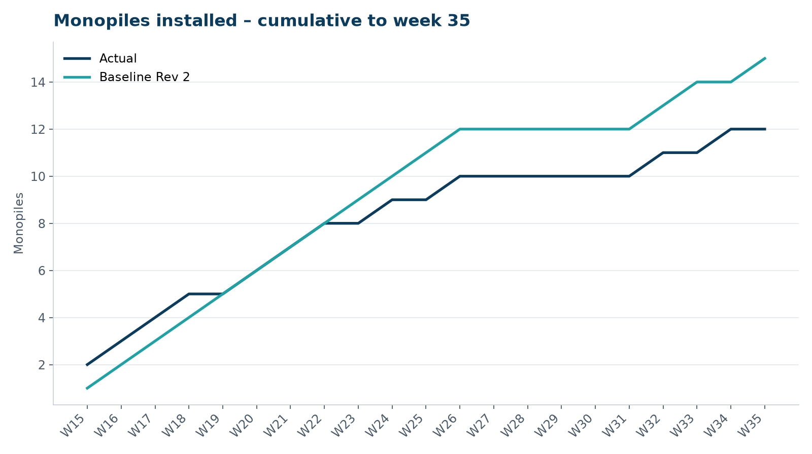
Figure 1 – Monopile installation progress, W15 to W35

3. Key activities this week
- Transition piece HB-A12 installed on 26 August.
- MV Sea Atlas transited to the Port of Eastholm for load-out of HB-A14, HB-B01 and HB-B02 (27–29 August).
- OSS hook-up and commissioning team mobilised (32 persons, walk-to-work vessel).

4. Health and safety
No lost time injuries. 29 observation cards submitted; top theme: hand protection.

5. Environment
- No piling this week; passive acoustic monitoring stations HB-PAM-01 to -04 operational.

6. Issues and risks
- HB-RISK-017 export cable 2 delay – recovery programme received; resequencing of cable lay campaign in progress.
- HB-RISK-001 weather: 26 h downtime this week.

7. Look-ahead next week
Install HB-A13 and HB-A14.
Prepared by Project Controls (Gareth Lewis); approved by Elena Márquez. Distribution: project team, Steering Committee, Halden Turbine Systems, Lenders' Technical Adviser.

